EXPERIMENT 10

Name: Arav Desai | Roll No: 3
Subject: Programming and problem solving | Class/Batch: AIML A
Date of Performance: 14/8/2024 | Date of Submission:

Code

- Write a program with function to swap values of two elements (call by value & call by reference).
Call by value:-

#include <stdio.h>

// Function prototype for call by value
void swapByValue(int a, int b);

int main() {
int num1 = 5, num2 = 10;

printf("Before swap by value: num1 = %d, num2 = %d\n", num1, num2);
swapByValue(num1, num2);
printf("After swap by value: num1 = %d, num2 = %d\n", num1, num2); // Values remain unchanged

return 0;
}

// Function definition
void swapByValue(int a, int b) {
int temp = a;
a = b;
b = temp;
printf("Inside swap by value: a = %d, b = %d\n", a, b); // Swapped inside the function
}

Call by reference:-
#include <stdio.h>

// Function prototype for call by reference
void swapByReference(int *a, int *b);

int main() {
int num1 = 5, num2 = 10;

printf("Before swap by reference: num1 = %d, num2 = %d\n", num1, num2);
swapByReference(&num1, &num2);
printf("After swap by reference: num1 = %d, num2 = %d\n", num1, num2); // Values are swapped

return 0;
}

// Function definition
void swapByReference(int *a, int *b) {
int temp = *a;
*a = *b;
*b = temp;
printf("Inside swap by reference: a = %d, b = %d\n", *a, *b); // Swapped and changes reflect outside
}
Output

Call by value:-
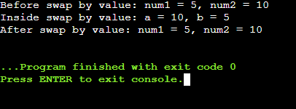
Call by reference:-

Code
- Perform basic file operations using C programs
Creating and writing a file:-
#include <stdio.h>

int main() {
FILE *filePointer;
filePointer = fopen("example.txt", "w"); // Open file in write mode

if (filePointer == NULL) {
printf("Failed to create the file.\n");
return 1;
}

fprintf(filePointer, "Hello, world!\n");
fprintf(filePointer, "This is a test file.\n");

fclose(filePointer); // Close the file
printf("File written successfully.\n");

return 0;
}
Reading a file:-
#include <stdio.h>

int main() {
FILE *filePointer;
char buffer[255];

filePointer = fopen("example.txt", "r"); // Open file in read mode

if (filePointer == NULL) {
printf("Failed to open the file.\n");
return 1;
}

while (fgets(buffer, 255, filePointer)) {
printf("%s", buffer); // Print each line of the file
}

fclose(filePointer); // Close the file
printf("\nFile read successfully.\n");

return 0;
}
Appending a file:-
#include <stdio.h>

int main() {
FILE *filePointer;
filePointer = fopen("example.txt", "a"); // Open file in append mode

if (filePointer == NULL) {
printf("Failed to open the file.\n");
return 1;
}

fprintf(filePointer, "Appending a new line.\n");

fclose(filePointer); // Close the file
printf("File appended successfully.\n");

return 0;
}
Output

Creating and writing a file:-
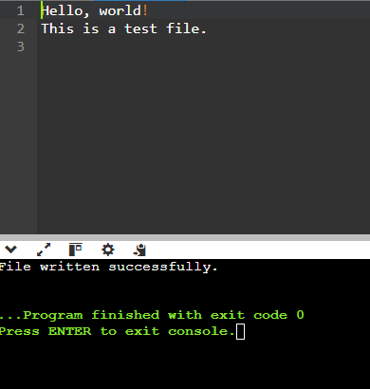
Reading a file:-
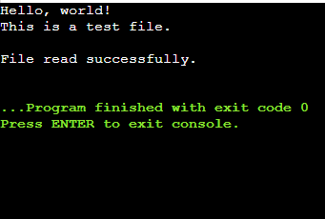
Appending a file:-
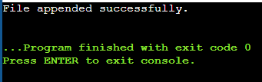

Conclusion
In conclusion, the recent exploration of function-based swapping techniques and file operations in C has significantly enhanced our understanding of practical programming applications. By implementing both call-by-value and call-by-reference methods, we gained insight into how different parameter passing mechanisms affect data manipulation within functions. Moreover, the comprehensive dive into basic file operations—covering file creation, writing, reading, and appending—equipped us with essential skills for managing data storage and retrieval in C programming.
Assessment

Timely Submission  (7) | Presentation  (06) | Understanding  (12) | Total  (25) | Sign

